1. Copy all files and images folder to a folder

I use NetworkComputing/Project

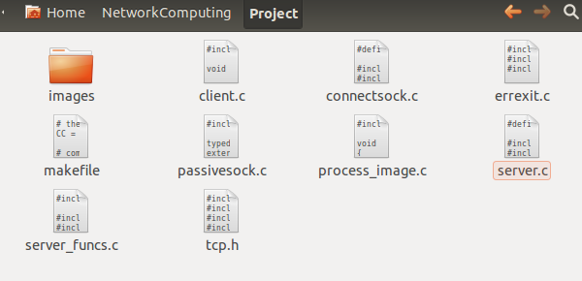

1. Create a folder for web home page

I use CMPE207

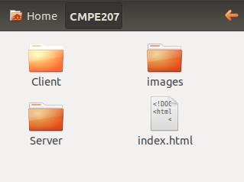

Copy index.html in Web Page folder

Create a folder images and copy images in Web Page /images folder

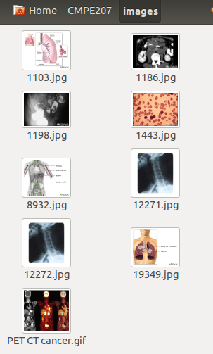

**Build and Start server/client**

make clean

make

./server –r /home/chungsik/CMPE207

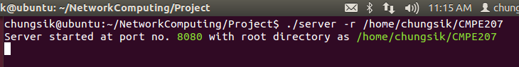

Server starts and listen HTTP request at port 8080 and TCP request 8081

**HTTP client**

Start browser localhost:8080

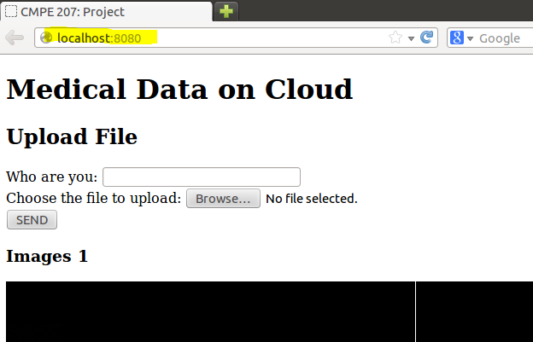

**TCP client**

Get image (fig1.jpg) from images folder and save the image in project folder

